DIGITAL ELECTRONICS AND LOGIC DESIGN[EC - 207]



**SARDAR VALLABHBHAI NATIONAL INSTITUTE OF TECHNOLOGY, SURAT ELECTRONICS ENGINEERINGDEPARTMENT**

|  |  |  |  |  |  |  |  |
| --- | --- | --- | --- | --- | --- | --- | --- |
|  |  |  |  |  |  |  |  |
| **Expt. No:** | |  | **3** |  |  |  |  |
|  |  |  |  |  | **Diode Clipper Circuits** |  |  |
| **Date:** |  | **16-08-21** | |  |  |
|  |  |  |  |  |
|  |  |  |  |  |  |  |  |
|  |  |  |  |  |  |  |  |

**NAME: Krishna Pandey**

**ADM NO: U20CS110**

**AIM:** To implement various Diode clipper circuits and verify its performance using Multi-Sim simulator

**SOFTWARE TOOLS / OTHER REQUIREMENTS:**

1. Multisim Simulator/Circuit Simulator

**THEORY:**

We know that when a diode is forward biased it allows current to pass through itself clamping the voltage across it to 0.7 volts (Practical Silicon Diode). While, when it is reverse biased, no current flows through it and the voltage across its terminals is unaffected, and this is the basic operation of the diode clipping circuit.

*Clippers are networks that employ diodes to “clip” away a portion of an input signal without distorting the remaining part of the applied waveform.*

There are two general categories of clippers: Series and Parallel. The series configuration is defined as the one where the diode is in series with the load, whereas the parallel variety has the diode in a branch parallel to the load.

|  |  |  |
| --- | --- | --- |
| **SERIES CONFIGURATIONS:** |  |  |
| NEGATIVE CLIPPER |  |  |
| As shown above, when the positive half cycle appears, the diode being forward |  |  |
| biased, acts as short circuit and allows the input voltage to appear across the load |  |  |
| resistor. During the negative half cycle, the diode is reverse biased, acts as open | 1page |  |
|  |  |



Exp-1- Diode Clippers ECED, SVNIT

DIGITAL ELECTRONICS AND LOGIC DESIGN[EC - 207]



**SARDAR VALLABHBHAI NATIONAL INSTITUTE OF TECHNOLOGY, SURAT ELECTRONICS ENGINEERINGDEPARTMENT**



circuit and hence we see that there is no connection between the output and input node, thereby the output voltage level remains at zero. Since the negative cycle of the input is getting clipped-off, the configuration in the above circuit is known as negative clipper.

Likewise when the polarity of the diode is reversed, we can clipp-off the positive half of the input cycle. In this case, during the positive half cycle, the diode remains reverse biased thereby disconnecting the output node from input node and the output voltage level remains at zero. But when the negative half cycle appears, the diode gets forward biased and allows the entire input to appear across the output load resistance.

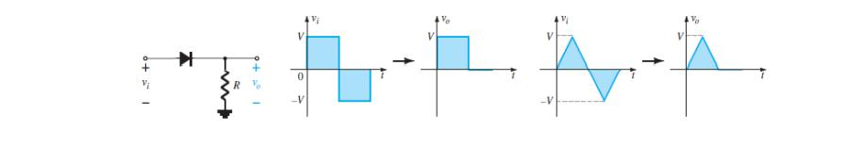

**SHUNT CONFIGURATIONS:**

As shown above, when the positive half cycle appears, the diode being forward biased, acts as short circuit and thus the output voltage remains at zero level. During the negative half cycle, the diode is reverse biased, acts as open circuit and hence we see that the output node comes into direct contact with the input node, thereby the output follows the input. Since the positive cycle of the input is getting clipped-off, the configuration in the above circuit is known as shunt positive clipper.

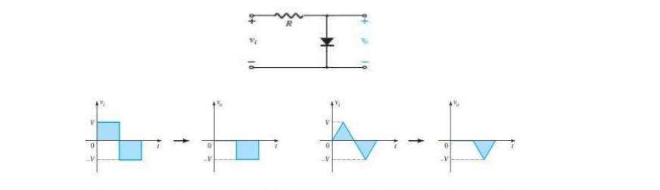

Likewiseif the polarity of the diode is reversed; we can clipp-off the negative half of



|  |
| --- |
| Page2 |

Exp-1- Diode Clippers ECED, SVNIT

DIGITAL ELECTRONICS AND LOGIC DESIGN[EC - 207]



**SARDAR VALLABHBHAI NATIONAL INSTITUTE OF TECHNOLOGY, SURAT ELECTRONICS ENGINEERINGDEPARTMENT**



the input cycle. In this case, during the positive half cycle, the diode remains reverse biased thereby connecting the output node with input node and the output voltage follows the input. But when the negative half cycle appears, the diode gets forward biased creating a short across the output nodes resulting into a zero voltage at the output. The level will be 0.7 if a silicon diode is considered instead of an non-ideal diode.

**FEW SHUNT DIODE CLIPPER CONFIGURATIONS:**

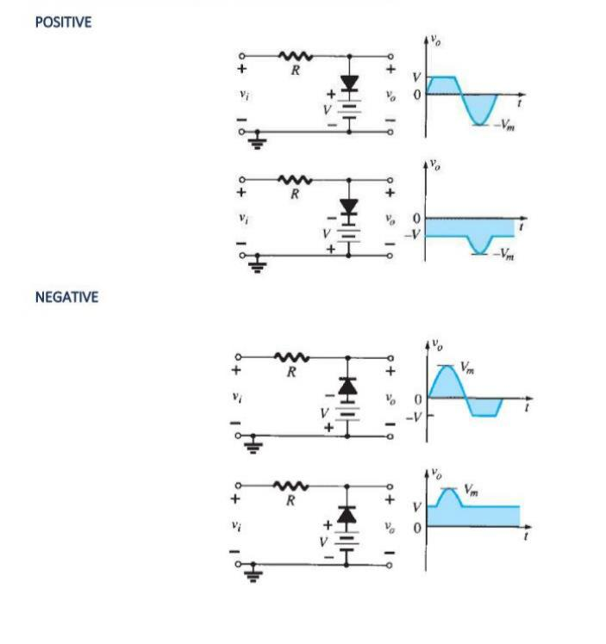

|  |
| --- |
| Page3 |



Exp-1- Diode Clippers ECED, SVNIT

DIGITAL ELECTRONICS AND LOGIC DESIGN[EC - 207]



**SARDAR VALLABHBHAI NATIONAL INSTITUTE OF TECHNOLOGY, SURAT ELECTRONICS ENGINEERINGDEPARTMENT**



**TWO LEVEL CLIPPERS:**

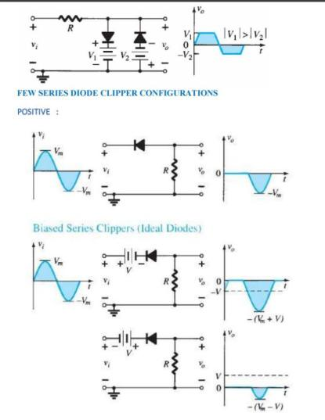

|  |
| --- |
| Page4 |



Exp-1- Diode Clippers ECED, SVNIT

DIGITAL ELECTRONICS AND LOGIC DESIGN[EC - 207]



**SARDAR VALLABHBHAI NATIONAL INSTITUTE OF TECHNOLOGY, SURAT ELECTRONICS ENGINEERINGDEPARTMENT**

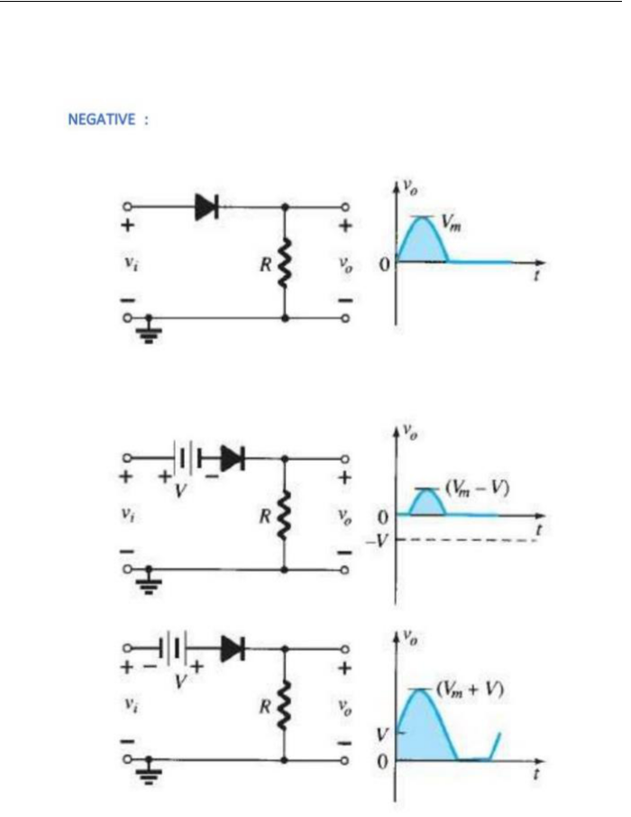

|  |
| --- |
| Page5 |



Exp-1- Diode Clippers ECED, SVNIT

DIGITAL ELECTRONICS AND LOGIC DESIGN[EC - 207]



**SARDAR VALLABHBHAI NATIONAL INSTITUTE OF TECHNOLOGY, SURAT ELECTRONICS ENGINEERINGDEPARTMENT**



**SIMPLE SERIES CLIPPERS (IDEAL DIODES):**

**POSITIVE:**

**CIRCUIT/CONNECTION DIAGRAMS (FROM MULTISIM)**

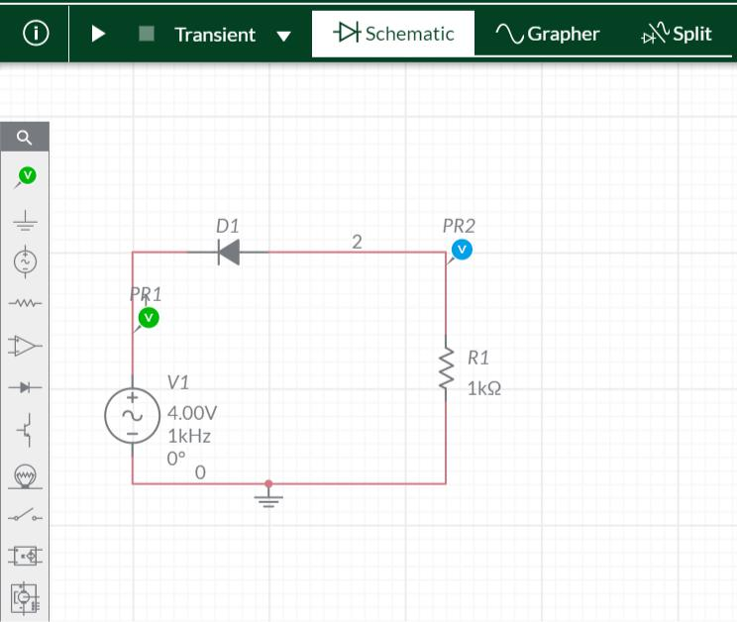

**WAVEFORMS (FROM MULTISIM)**

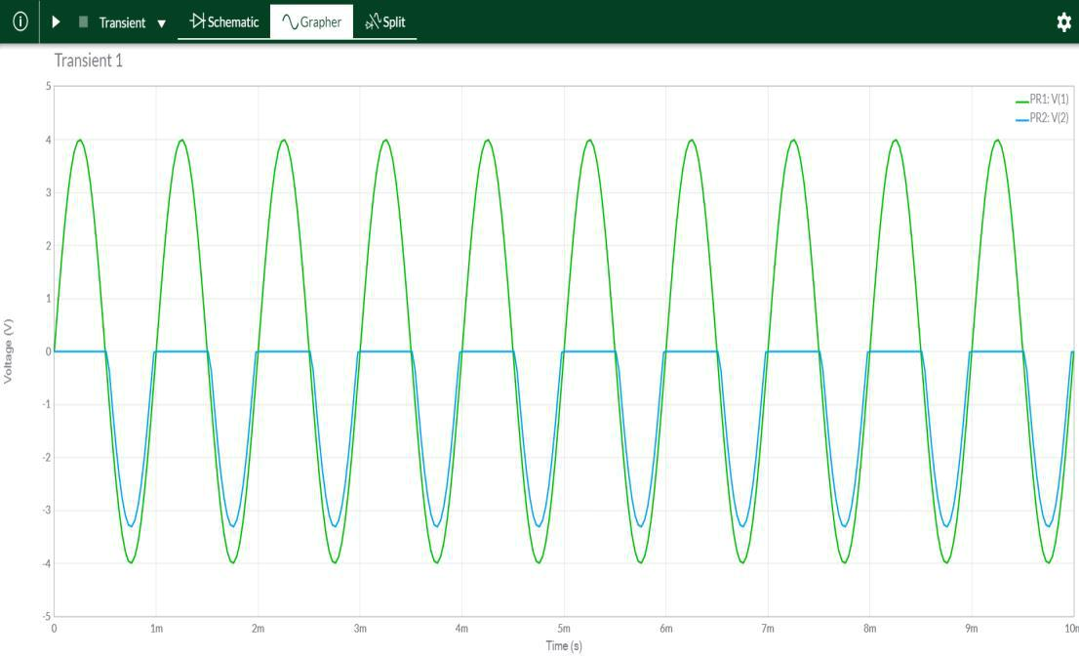

|  |
| --- |
| Page6 |



Exp-1- Diode Clippers ECED, SVNIT

DIGITAL ELECTRONICS AND LOGIC DESIGN[EC - 207]



**SARDAR VALLABHBHAI NATIONAL INSTITUTE OF TECHNOLOGY, SURAT ELECTRONICS ENGINEERINGDEPARTMENT**



**SIMPLE SERIES CLIPPERS (IDEAL DIODES):**

**NEGATIVE:**

**CIRCUIT/CONNECTION DIAGRAMS (FROM MULTISIM)**

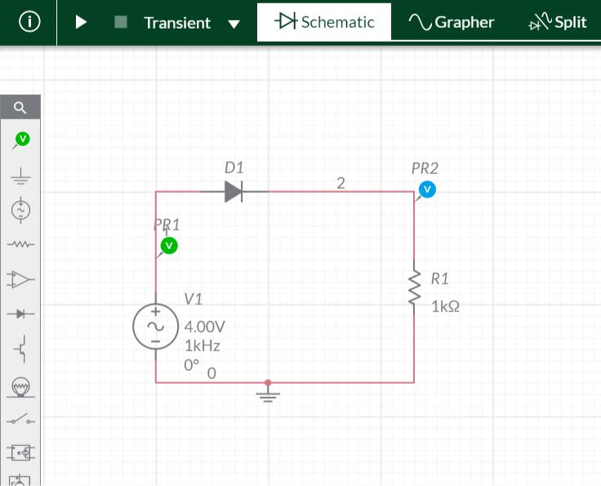

**WAVEFORMS (FROM MULTISIM)**

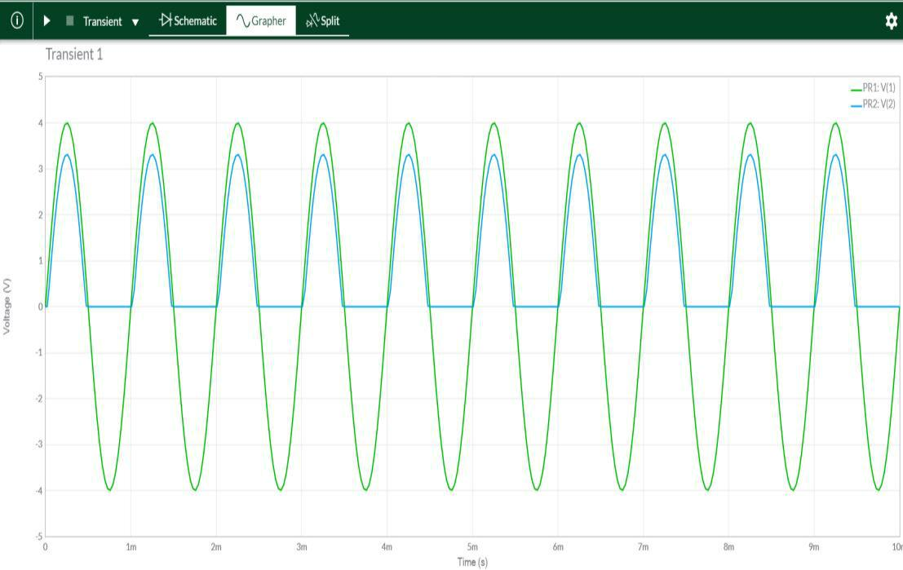

|  |
| --- |
| Page7 |



Exp-1- Diode Clippers ECED, SVNIT

DIGITAL ELECTRONICS AND LOGIC DESIGN[EC - 207]



**SARDAR VALLABHBHAI NATIONAL INSTITUTE OF TECHNOLOGY, SURAT ELECTRONICS ENGINEERINGDEPARTMENT**



**BIASED SERIES CLIPPERS (IDEAL DIODES)**

**POSITIVE:**

**CIRCUIT/CONNECTION DIAGRAMS (FROM MULTISIM)**

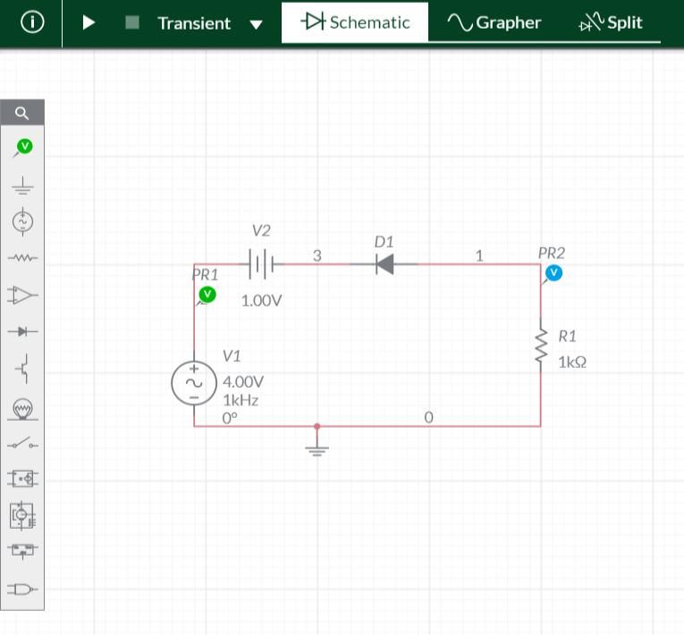

**WAVEFORMS (FROM MULTISIM)**

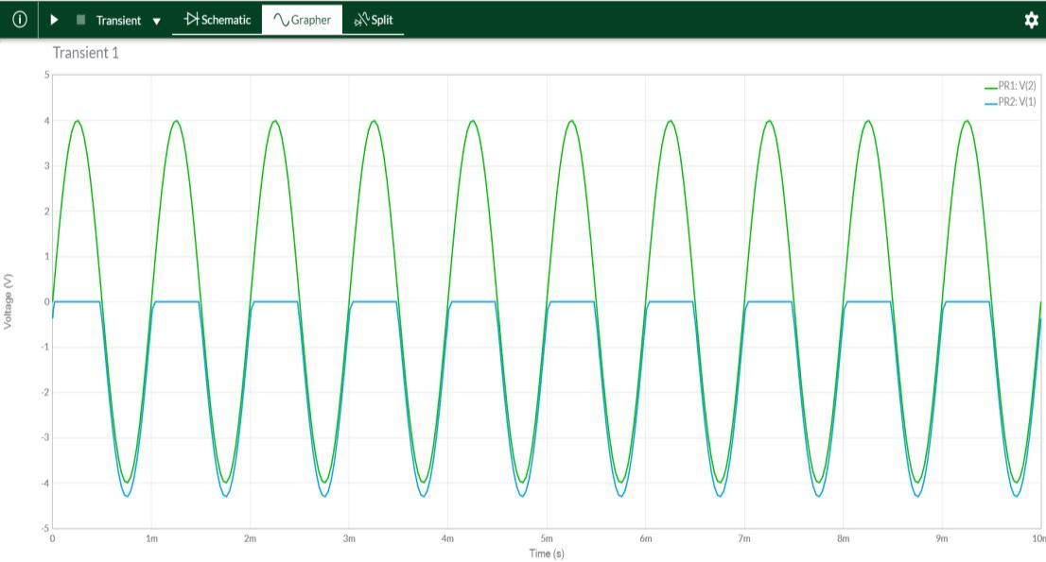

|  |
| --- |
| Page8 |



Exp-1- Diode Clippers ECED, SVNIT

DIGITAL ELECTRONICS AND LOGIC DESIGN[EC - 207]



**SARDAR VALLABHBHAI NATIONAL INSTITUTE OF TECHNOLOGY, SURAT ELECTRONICS ENGINEERINGDEPARTMENT**



**CIRCUIT/CONNECTION DIAGRAMS (FROM MULTISIM)**

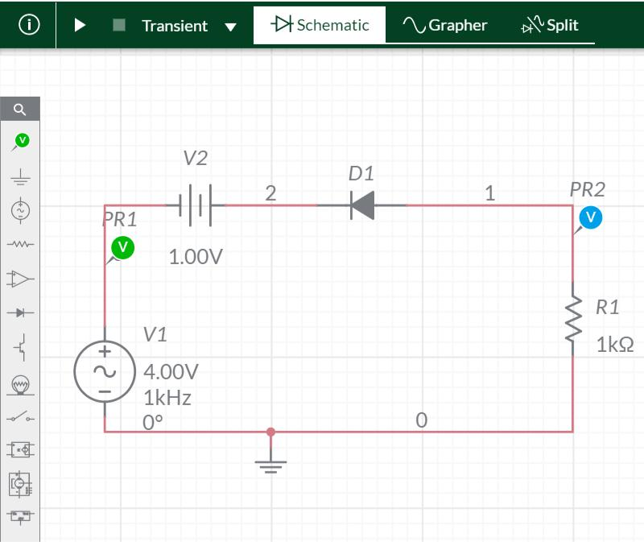

**WAVEFORMS (FROM MULTISIM)**

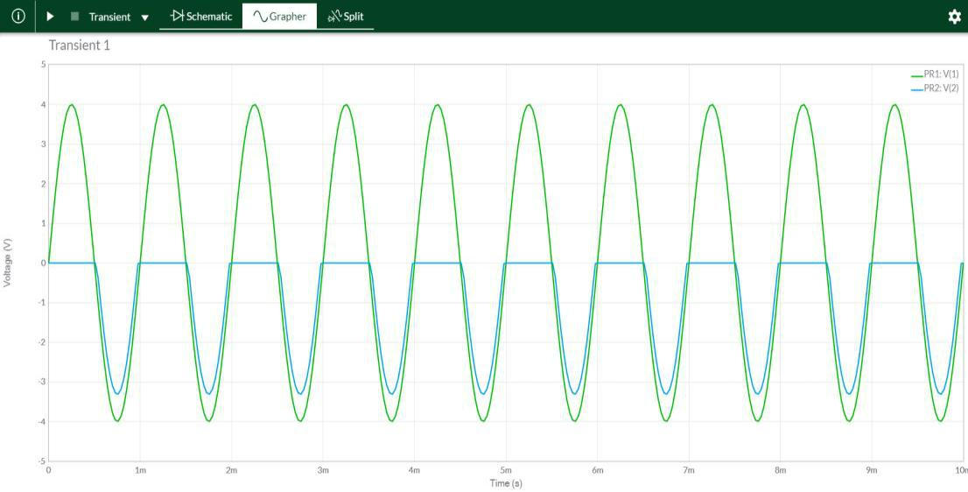

**BIASED SERIES CLIPPERS (IDEAL DIODES)**



|  |
| --- |
| Page9 |

Exp-1 Diode Clippers ECED, SVNIT

DIGITAL ELECTRONICS AND LOGIC DESIGN[EC - 207]



**SARDAR VALLABHBHAI NATIONAL INSTITUTE OF TECHNOLOGY, SURAT ELECTRONICS ENGINEERINGDEPARTMENT**



**NEGATIVE:**

**CIRCUIT/CONNECTION DIAGRAMS (FROM MULTISIM)**

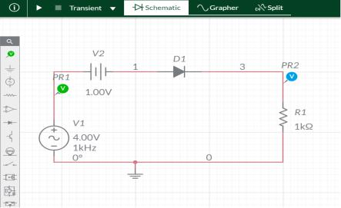

**WAVEFORMS (FROM MULTISIM)**

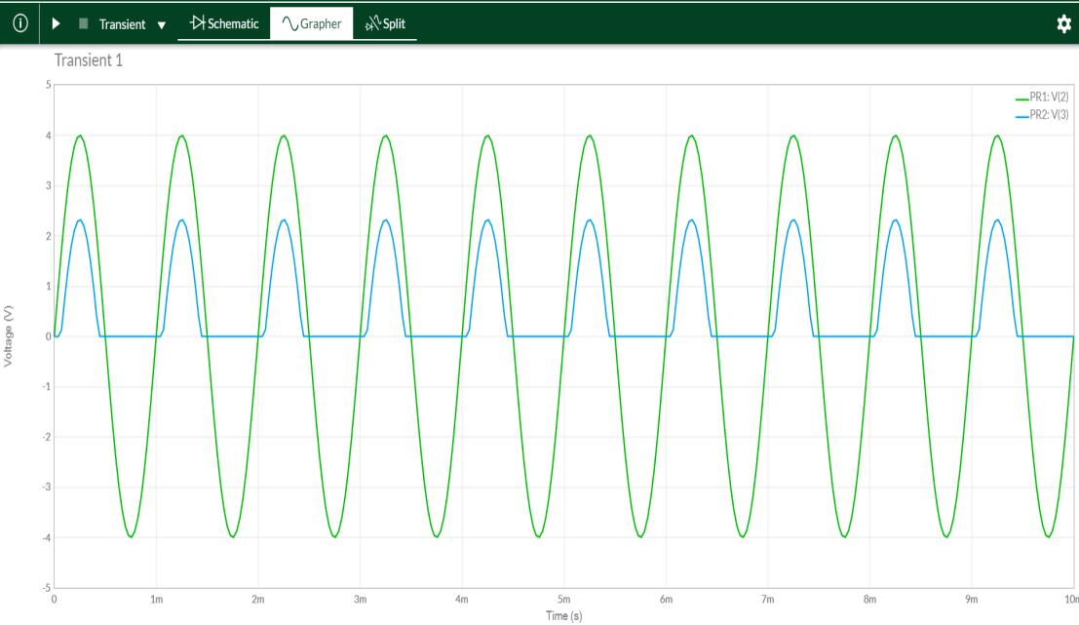

|  |
| --- |
| Page10 |



Exp-1- Diode Clippers ECED, SVNIT

DIGITAL ELECTRONICS AND LOGIC DESIGN[EC - 207]



**SARDAR VALLABHBHAI NATIONAL INSTITUTE OF TECHNOLOGY, SURAT ELECTRONICS ENGINEERINGDEPARTMENT**



**CIRCUIT/CONNECTION DIAGRAMS (FROM MULTISIM)**

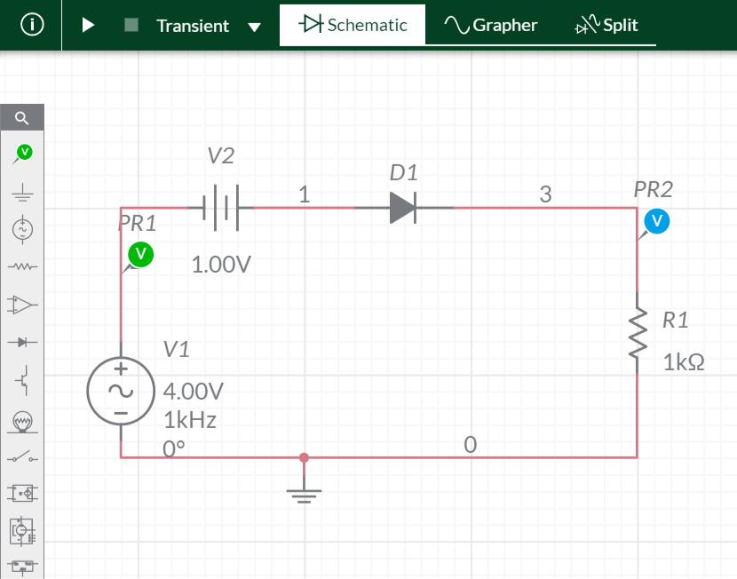

**WAVEFORMS (FROM MULTISIM)**

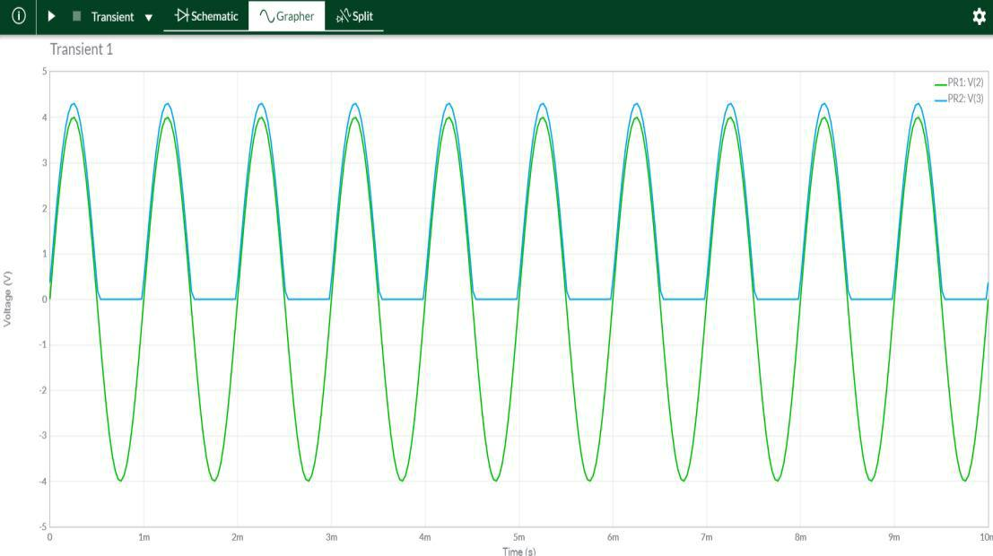

|  |
| --- |
| Page11 |



Exp-2- Diode Clippers ECED, SVNIT

DIGITAL ELECTRONICS AND LOGIC DESIGN[EC - 207]



**SARDAR VALLABHBHAI NATIONAL INSTITUTE OF TECHNOLOGY, SURAT ELECTRONICS ENGINEERINGDEPARTMENT**



**SIMPLE PARALLEL CLIPPERS (IDEAL DIODES)**

**POSITIVE:**

**CIRCUIT/CONNECTION DIAGRAMS (FROM MULTISIM)**

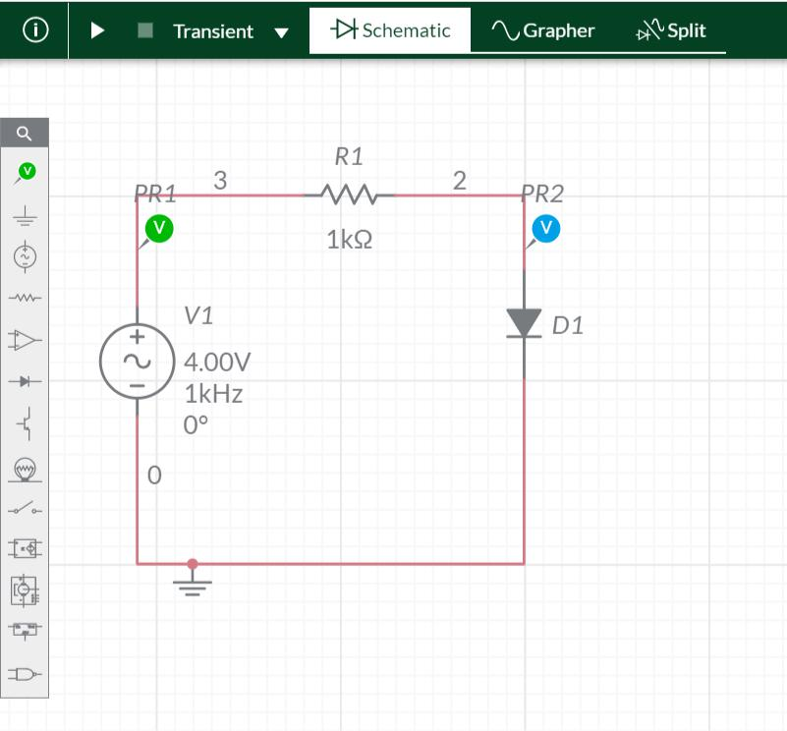

**WAVEFORMS (FROM MULTISIM)**

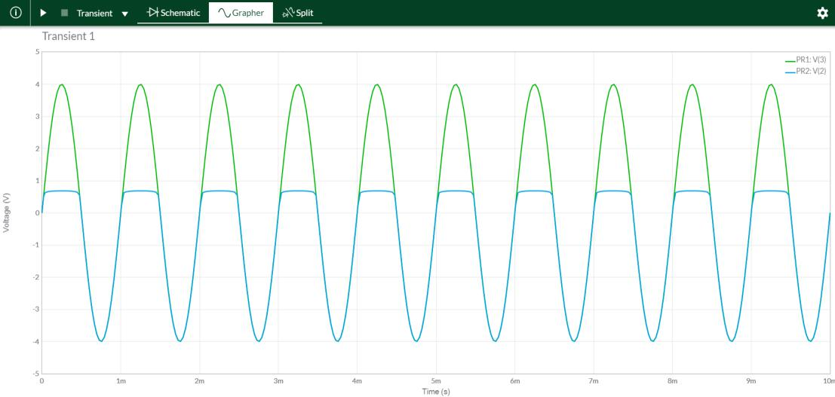

|  |
| --- |
| Page12 |



Exp-2- Diode Clippers ECED, SVNIT

DIGITAL ELECTRONICS AND LOGIC DESIGN[EC - 207]



**SARDAR VALLABHBHAI NATIONAL INSTITUTE OF TECHNOLOGY, SURAT ELECTRONICS ENGINEERINGDEPARTMENT**



**SIMPLE PARALLEL CLIPPERS (IDEAL DIODES)**

**NEGATIVE:**

**CIRCUIT/CONNECTION DIAGRAMS (FROM MULTISIM)**

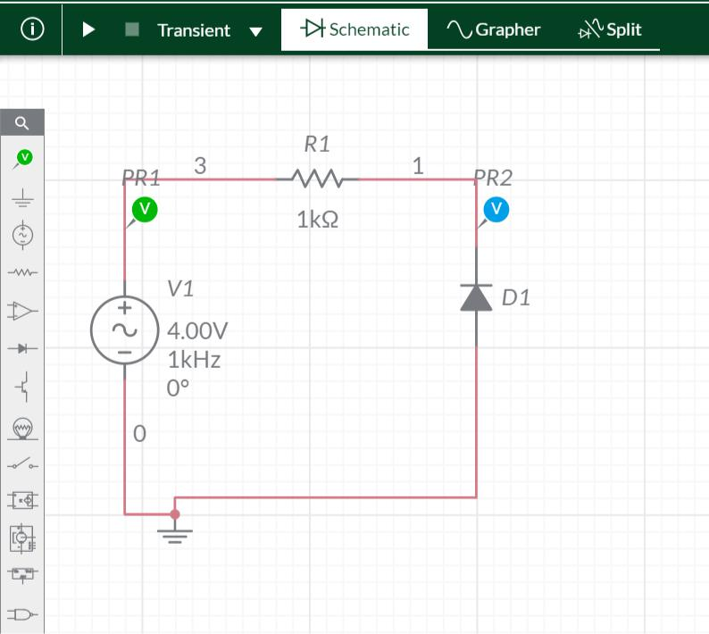

**WAVEFORMS (FROM MULTISIM)**

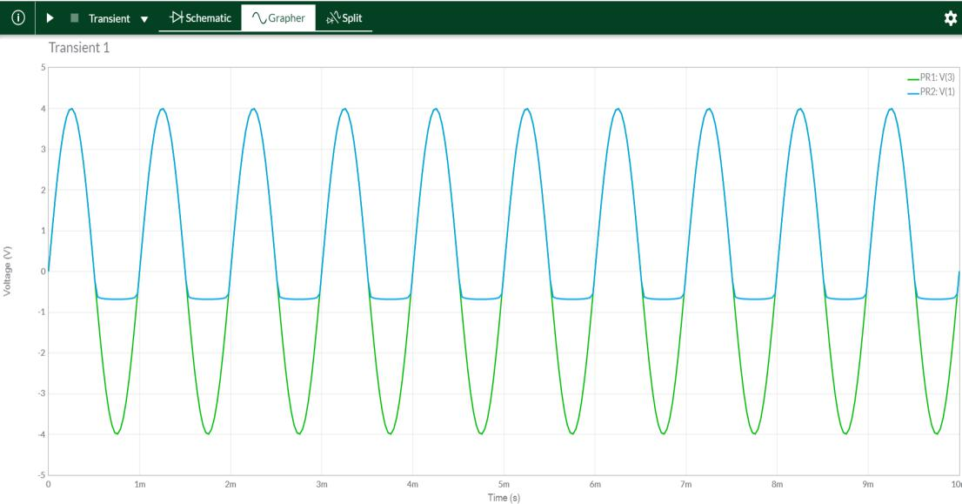

**BIASED PARALLEL CLIPPERS( IDEAL DIODES)**



|  |
| --- |
| Page13 |

Exp-2- Diode Clippers ECED, SVNIT

DIGITAL ELECTRONICS AND LOGIC DESIGN[EC - 207]



**SARDAR VALLABHBHAI NATIONAL INSTITUTE OF TECHNOLOGY, SURAT ELECTRONICS ENGINEERINGDEPARTMENT**



**POSITIVE:**

**CIRCUIT/CONNECTION DIAGRAMS (FROM MULTISIM)**

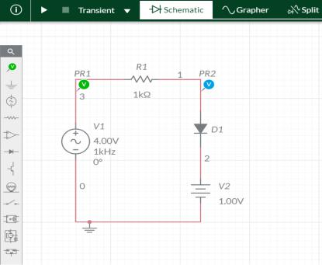

**WAVEFORMS (FROM MULTISIM)**

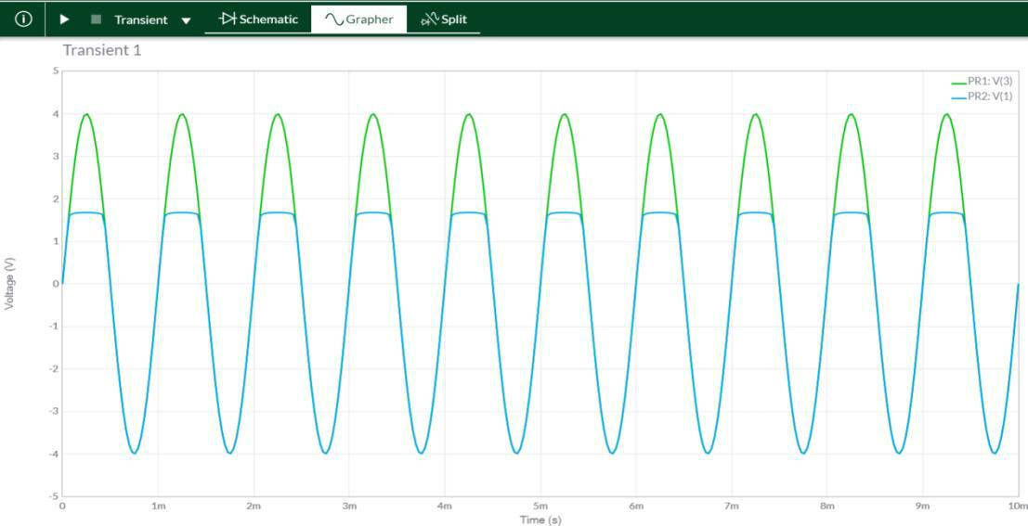

|  |
| --- |
| Page14 |



Exp-2- Diode Clippers ECED, SVNIT

DIGITAL ELECTRONICS AND LOGIC DESIGN[EC - 207]



**SARDAR VALLABHBHAI NATIONAL INSTITUTE OF TECHNOLOGY, SURAT ELECTRONICS ENGINEERINGDEPARTMENT**



**CIRCUIT/CONNECTION DIAGRAMS (FROM MULTISIM)**

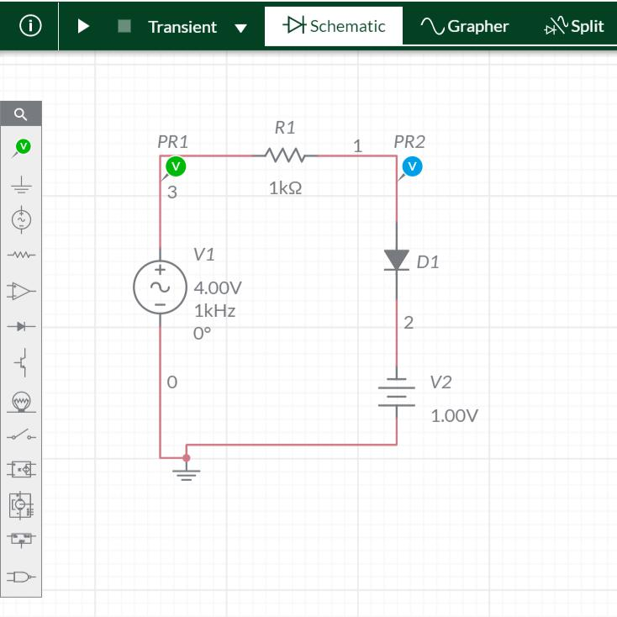

**WAVEFORMS (FROM MULTISIM)**

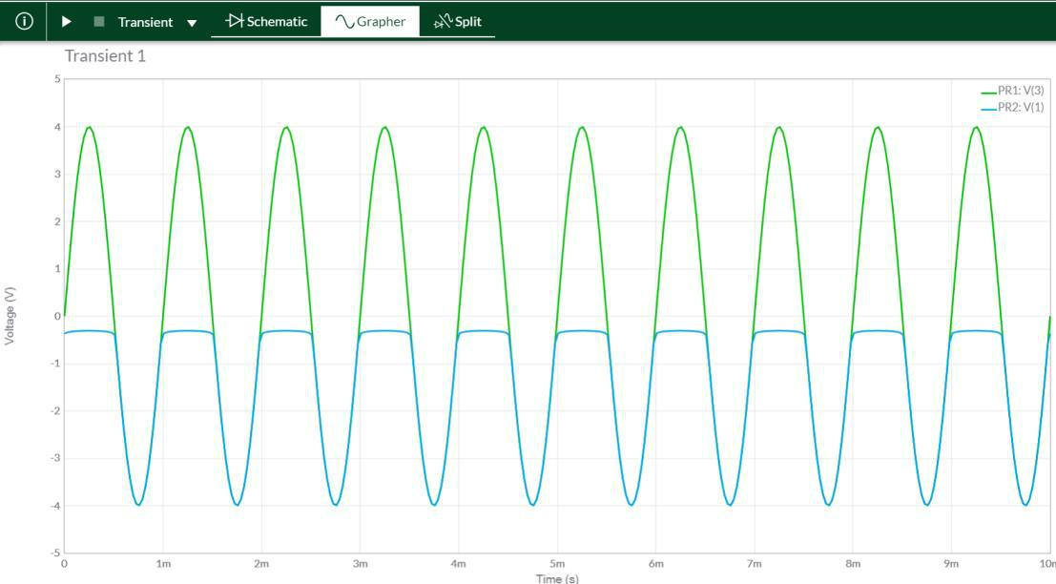

**BIASED PARALLEL CLIPPERS( IDEAL DIODES)**



|  |
| --- |
| Page15 |

Exp-2- Diode Clippers ECED, SVNIT

DIGITAL ELECTRONICS AND LOGIC DESIGN[EC - 207]



**SARDAR VALLABHBHAI NATIONAL INSTITUTE OF TECHNOLOGY, SURAT ELECTRONICS ENGINEERINGDEPARTMENT**



**NEGATIVE:**

**CIRCUIT/CONNECTION DIAGRAMS (FROM MULTISIM)**

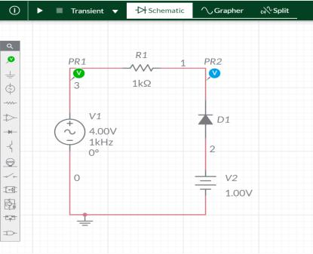

**WAVEFORMS (FROM MULTISIM)**

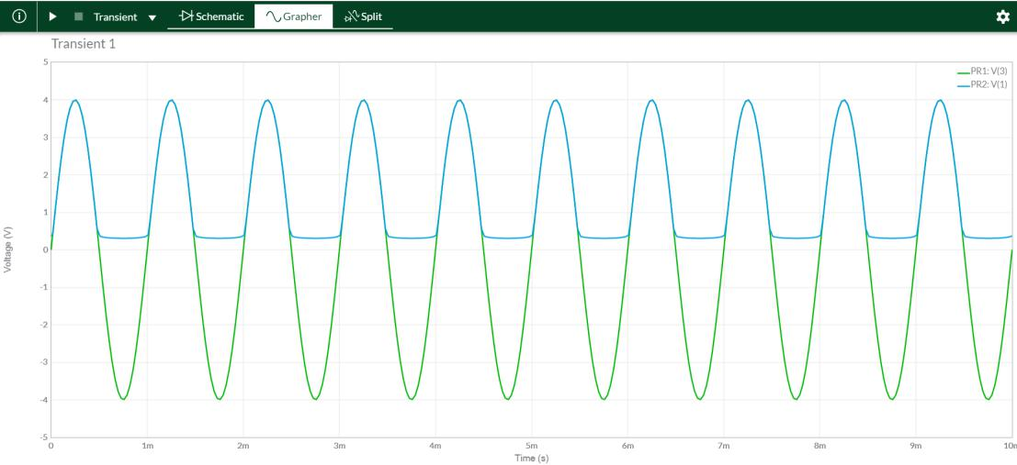

|  |
| --- |
| Page16 |



Exp-2- Diode Clippers ECED, SVNIT

DIGITAL ELECTRONICS AND LOGIC DESIGN[EC - 207]



**SARDAR VALLABHBHAI NATIONAL INSTITUTE OF TECHNOLOGY, SURAT ELECTRONICS ENGINEERINGDEPARTMENT**



**CIRCUIT/CONNECTION DIAGRAMS (FROM MULTISIM)**

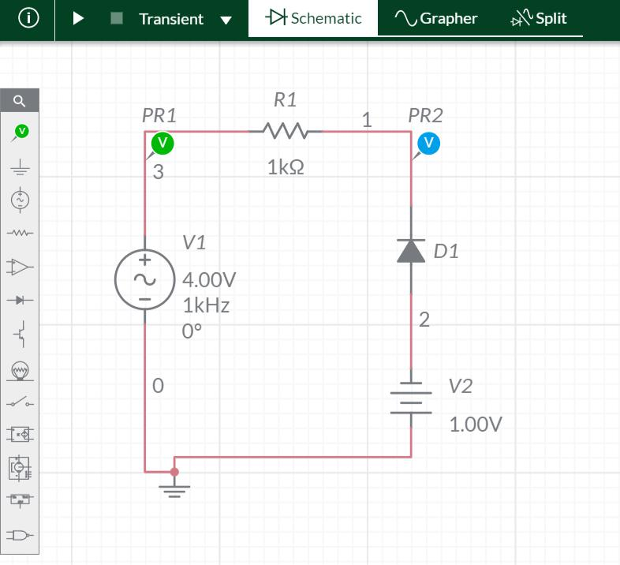

**WAVEFORMS (FROM MULTISIM)**

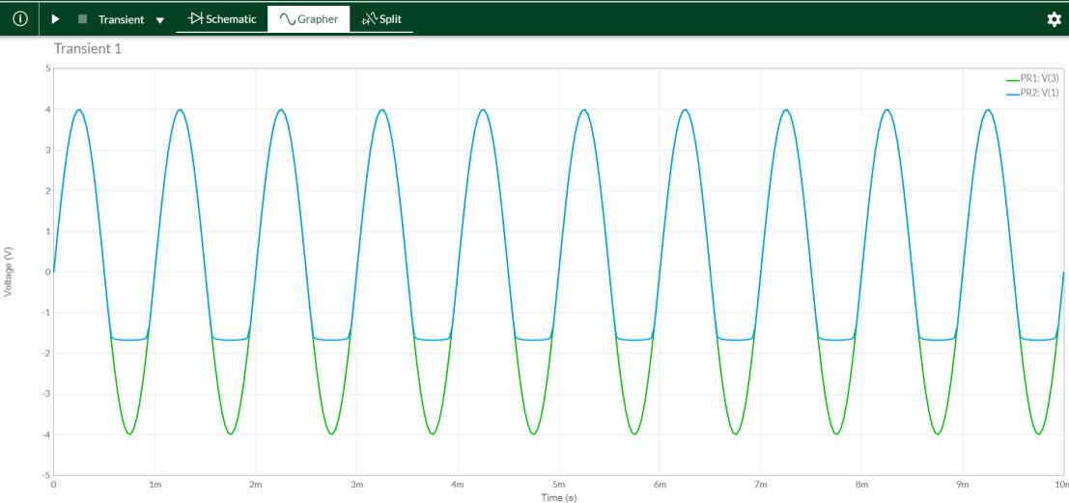

|  |
| --- |
| Page17 |



Exp-2- Diode Clippers ECED, SVNIT

DIGITAL ELECTRONICS AND LOGIC DESIGN[EC - 207]



**SARDAR VALLABHBHAI NATIONAL INSTITUTE OF TECHNOLOGY, SURAT ELECTRONICS ENGINEERINGDEPARTMENT**



**CIRCUIT/CONNECTION DIAGRAMS (FROM MULTISIM)**

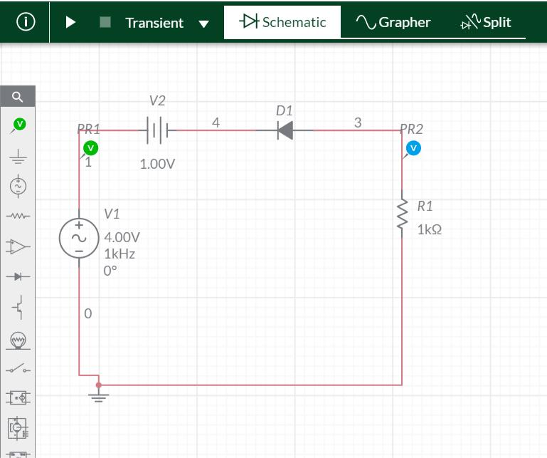

**WAVEFORMS (FROM MULTISIM)**

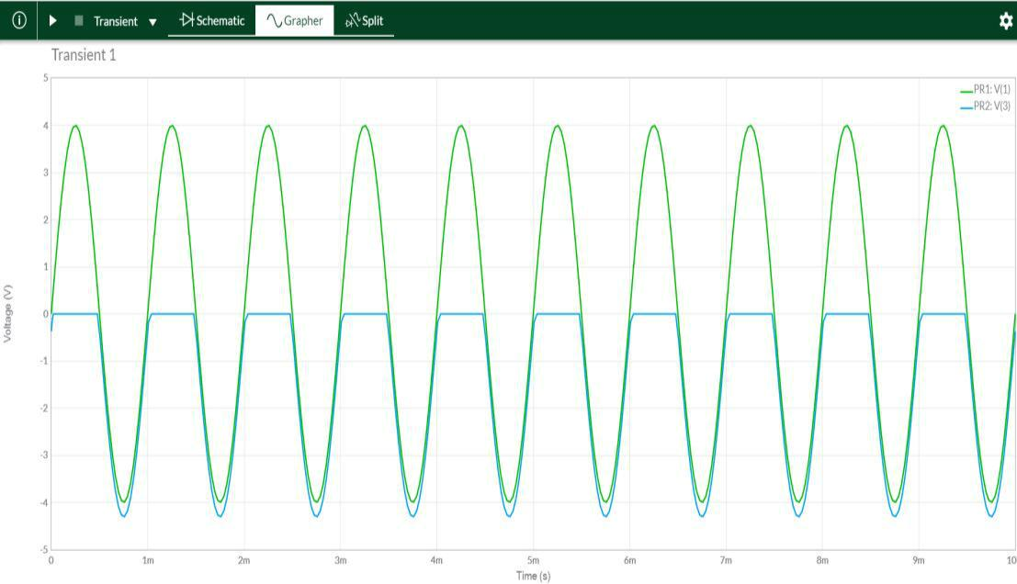

|  |
| --- |
| Page18 |



Exp-2- Diode Clippers ECED, SVNIT

DIGITAL ELECTRONICS AND LOGIC DESIGN[EC - 207]



**SARDAR VALLABHBHAI NATIONAL INSTITUTE OF TECHNOLOGY, SURAT ELECTRONICS ENGINEERINGDEPARTMENT**



**CIRCUIT/CONNECTION DIAGRAMS (FROM MULTISIM)**

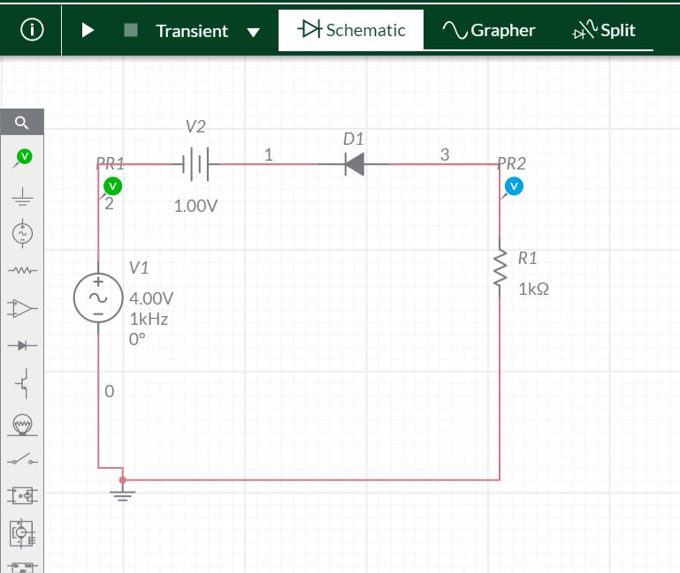

**WAVEFORMS (FROM MULTISIM)**

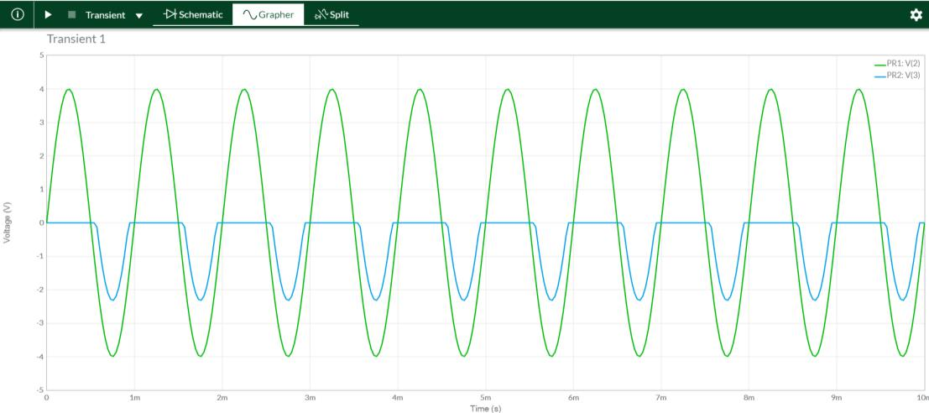

|  |
| --- |
| Page19 |



Exp-2- Diode Clippers ECED, SVNIT

DIGITAL ELECTRONICS AND LOGIC DESIGN[EC - 207]



**SARDAR VALLABHBHAI NATIONAL INSTITUTE OF TECHNOLOGY, SURAT ELECTRONICS ENGINEERINGDEPARTMENT**



**CIRCUIT/CONNECTION DIAGRAMS (FROM MULTISIM)**

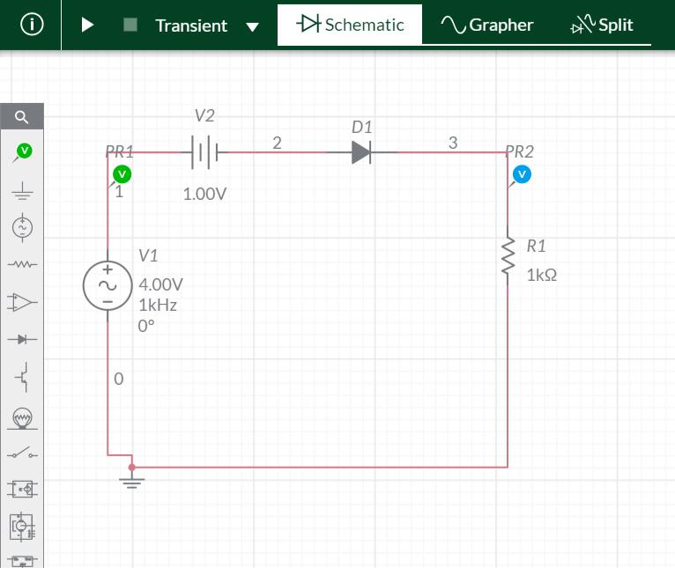

**WAVEFORMS (FROM MULTISIM)**

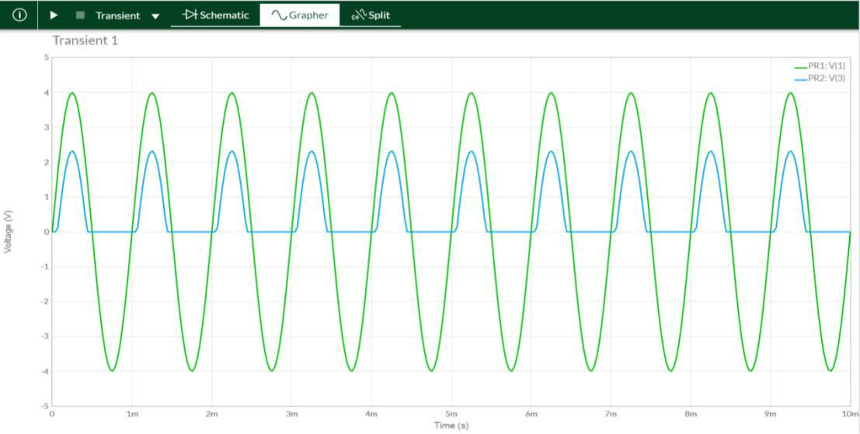

|  |
| --- |
| Page20 |



Exp-2- Diode Clippers ECED, SVNIT

DIGITAL ELECTRONICS AND LOGIC DESIGN[EC - 207]



**SARDAR VALLABHBHAI NATIONAL INSTITUTE OF TECHNOLOGY, SURAT ELECTRONICS ENGINEERINGDEPARTMENT**



**CIRCUIT/CONNECTION DIAGRAMS (FROM MULTISIM)**

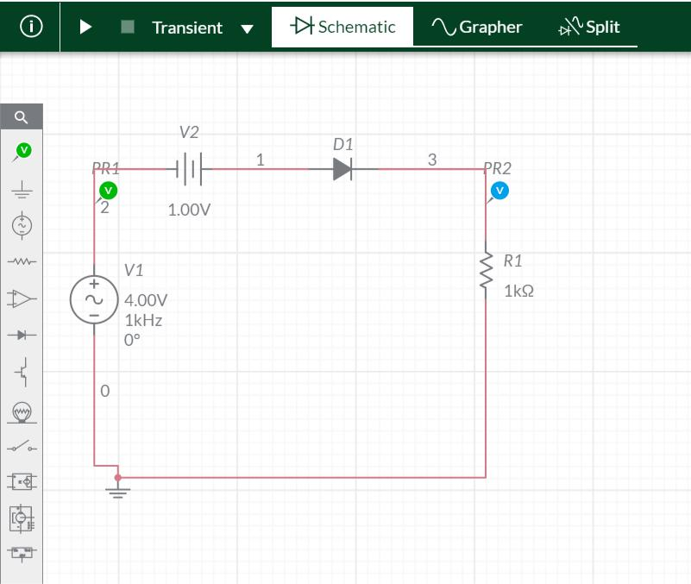

**WAVEFORMS (FROM MULTISIM)**

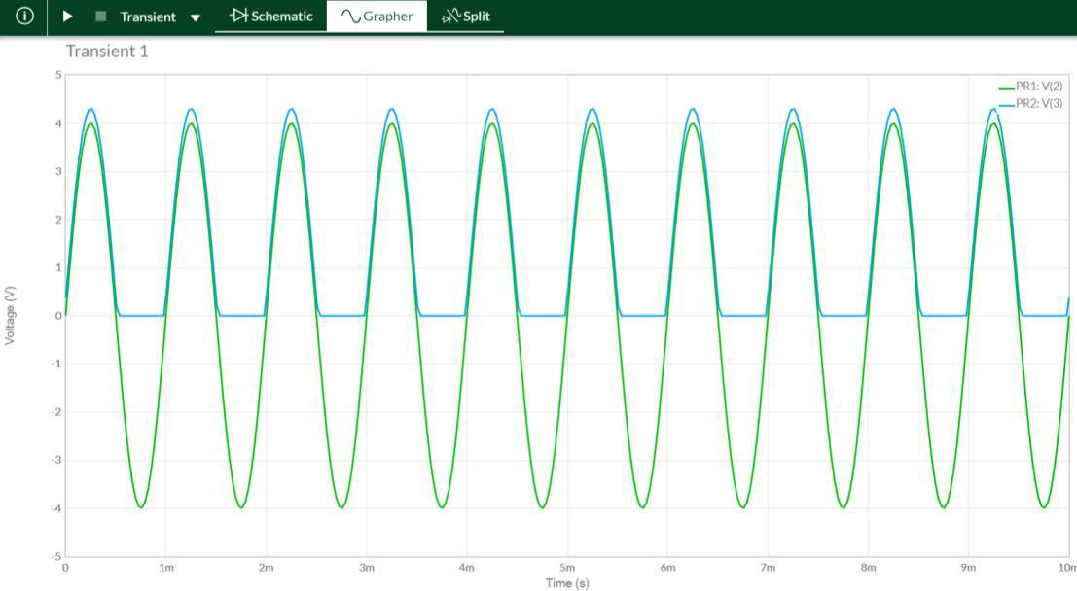

|  |
| --- |
| Page21 |



Exp-2- Diode Clippers ECED, SVNIT

DIGITAL ELECTRONICS AND LOGIC DESIGN[EC - 207]



**SARDAR VALLABHBHAI NATIONAL INSTITUTE OF TECHNOLOGY, SURAT ELECTRONICS ENGINEERINGDEPARTMENT**



**SIMPLE PARALLEL CLIPPERS(IDEAL DIODES)**

**POSITIVE:**

**CIRCUIT/CONNECTION DIAGRAMS (FROM MULTISIM)**

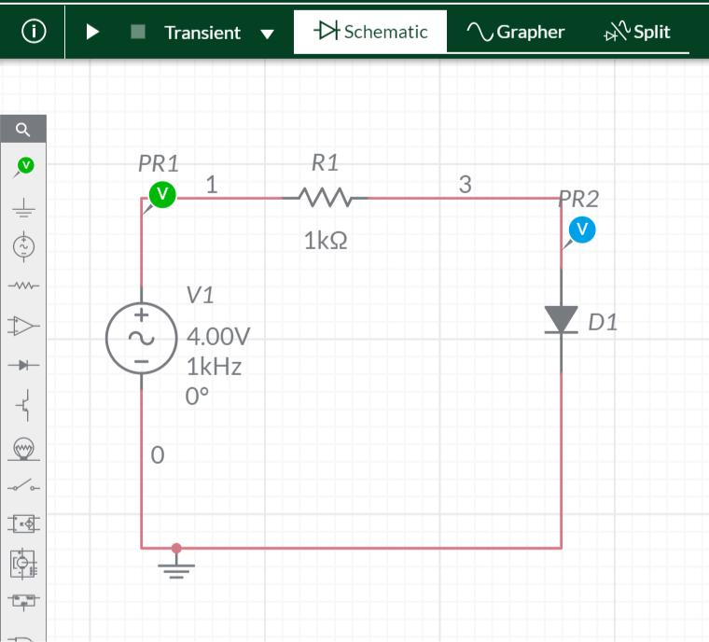

**WAVEFORMS (FROM MULTISIM)**

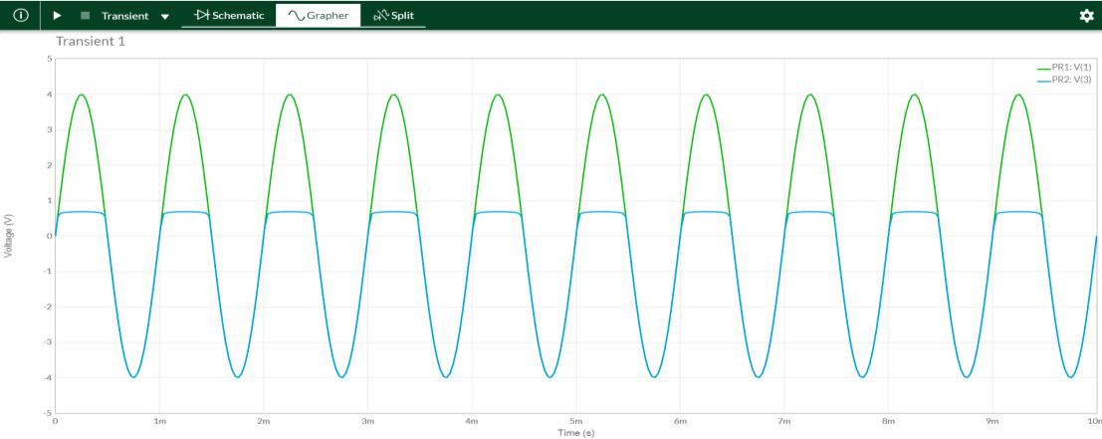

**SIMPLE PARALLEL CLIPPERS(IDEAL DIODES)**



|  |
| --- |
| Page22 |

Exp-2- Diode Clippers ECED, SVNIT

DIGITAL ELECTRONICS AND LOGIC DESIGN[EC - 207]



**SARDAR VALLABHBHAI NATIONAL INSTITUTE OF TECHNOLOGY, SURAT ELECTRONICS ENGINEERINGDEPARTMENT**



**NEGATIVE:**

**CIRCUIT/CONNECTION DIAGRAMS (FROM MULTISIM)**

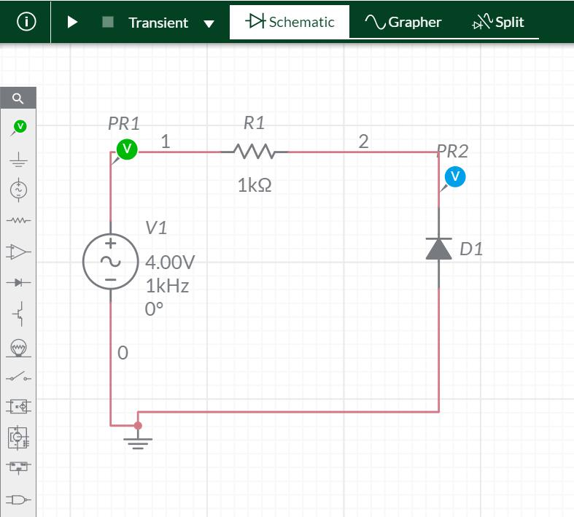

**WAVEFORMS (FROM MULTISIM)**

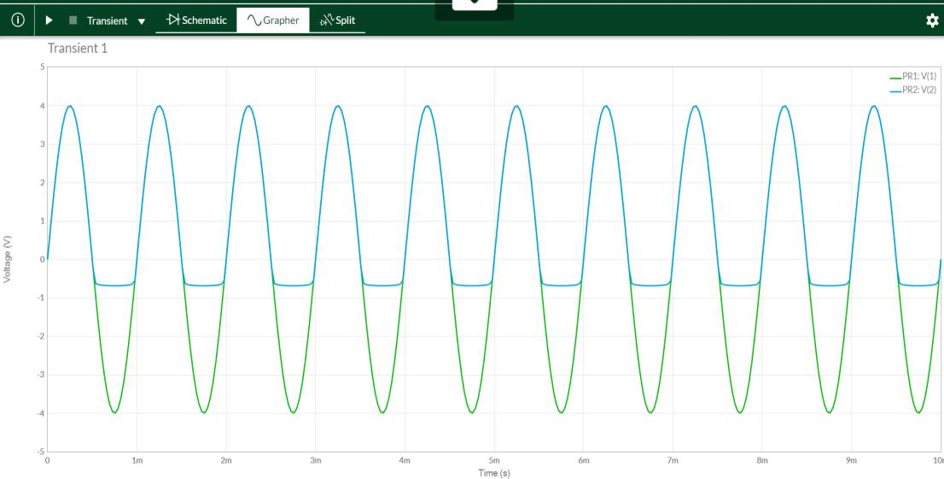

|  |
| --- |
| Page23 |



Exp-2- Diode Clippers ECED, SVNIT

DIGITAL ELECTRONICS AND LOGIC DESIGN[EC - 207]



**SARDAR VALLABHBHAI NATIONAL INSTITUTE OF TECHNOLOGY, SURAT ELECTRONICS ENGINEERINGDEPARTMENT**



**BIASED PARALLEL CLIPPERS(IDEAL DIODES):**

**POSITIVE:**

**CIRCUIT/CONNECTION DIAGRAMS (FROM MULTISIM)**

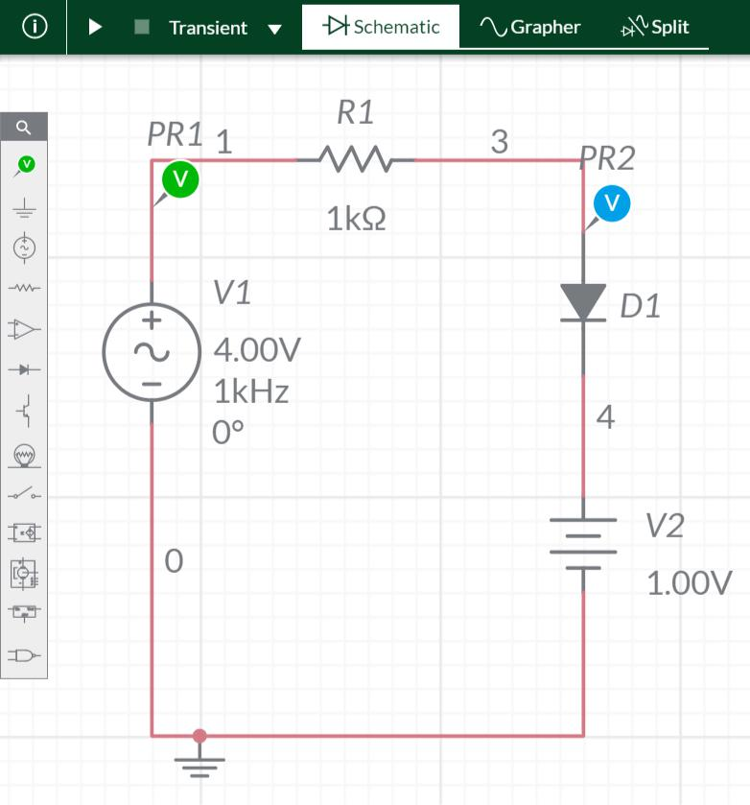

**WAVEFORMS (FROM MULTISIM)**

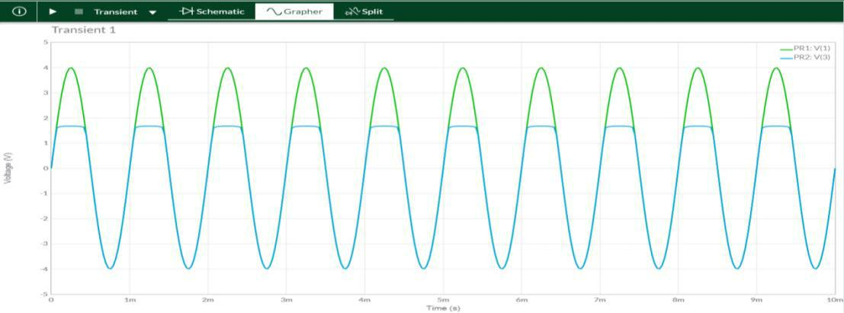

|  |
| --- |
| Page24 |



Exp-2- Diode Clippers ECED, SVNIT

DIGITAL ELECTRONICS AND LOGIC DESIGN[EC - 207]



**SARDAR VALLABHBHAI NATIONAL INSTITUTE OF TECHNOLOGY, SURAT ELECTRONICS ENGINEERINGDEPARTMENT**



**CIRCUIT/CONNECTION DIAGRAMS (FROM MULTISIM)**

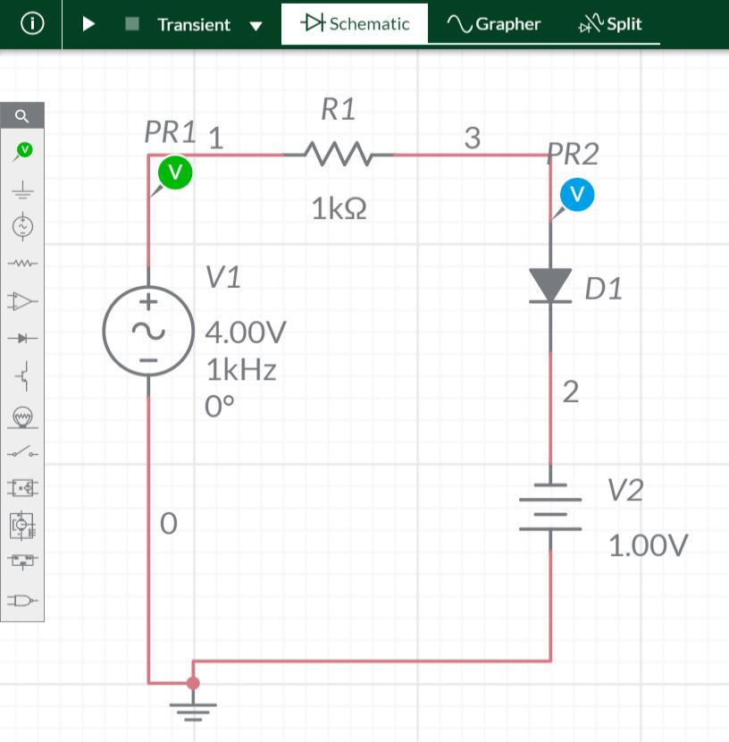

**WAVEFORMS (FROM MULTISIM)**

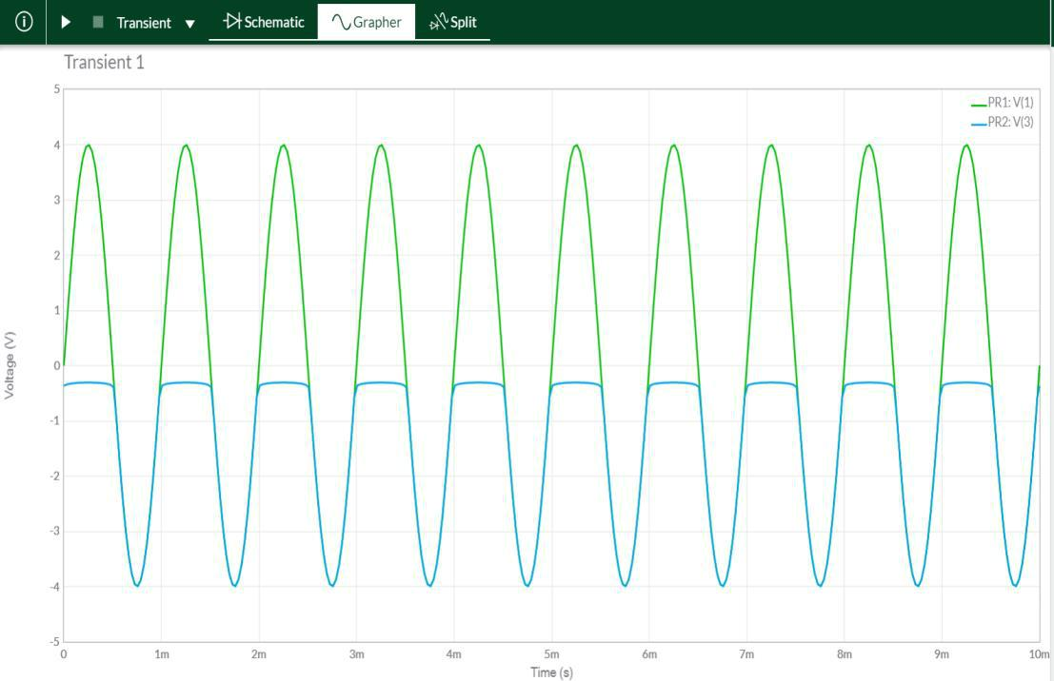

|  |
| --- |
| Page25 |



Exp-2- Diode Clippers ECED, SVNIT

DIGITAL ELECTRONICS AND LOGIC DESIGN[EC - 207]



**SARDAR VALLABHBHAI NATIONAL INSTITUTE OF TECHNOLOGY, SURAT ELECTRONICS ENGINEERINGDEPARTMENT**



**BIASED PARALLEL CLIPPERS(IDEAL DIODES):**

**NEGATIVE:**

**CIRCUIT/CONNECTION DIAGRAMS (FROM MULTISIM)**

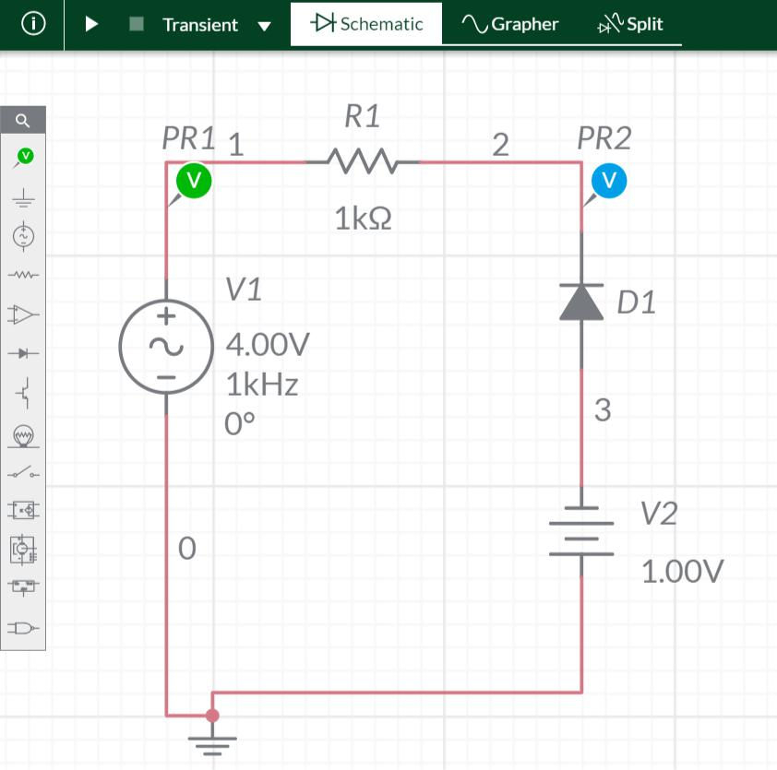

**WAVEFORMS (FROM MULTISIM)**

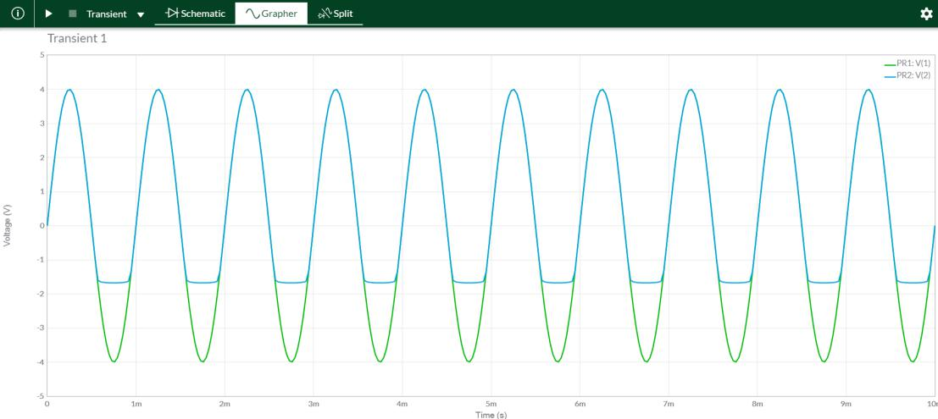

|  |
| --- |
| Page26 |



Exp-2- Diode Clippers ECED, SVNIT

DIGITAL ELECTRONICS AND LOGIC DESIGN[EC - 207]



**SARDAR VALLABHBHAI NATIONAL INSTITUTE OF TECHNOLOGY, SURAT ELECTRONICS ENGINEERINGDEPARTMENT**



**CIRCUIT/CONNECTION DIAGRAMS (FROM MULTISIM)**

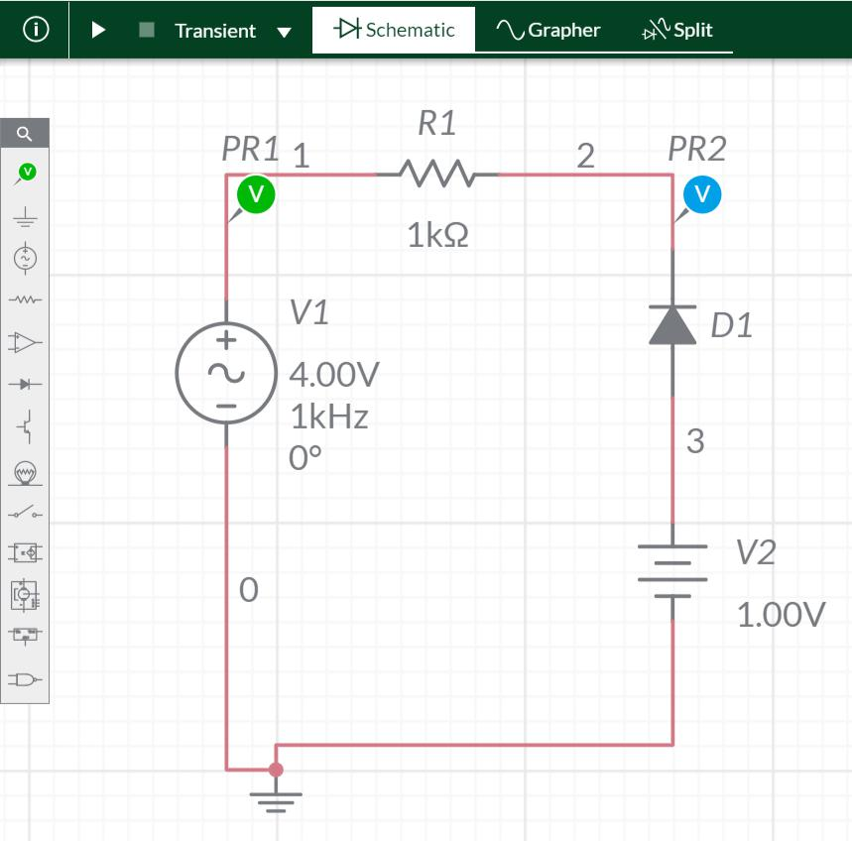

**WAVEFORMS (FROM MULTISIM)**

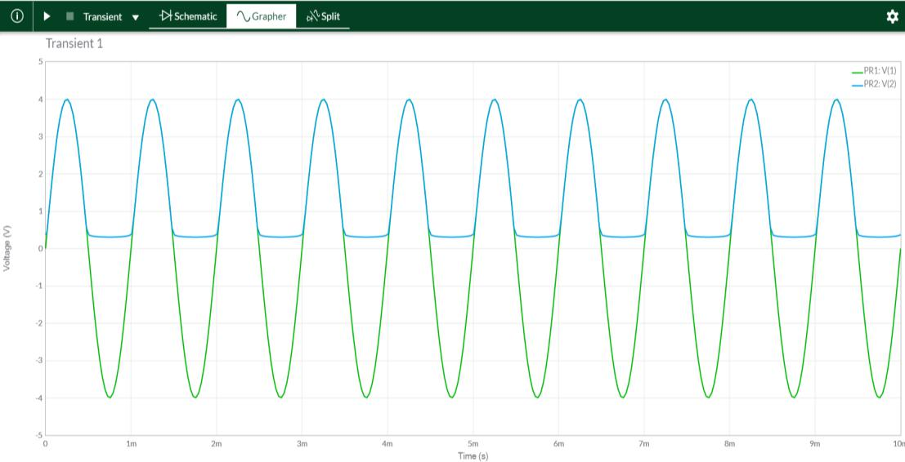

|  |
| --- |
| Page27 |



Exp-1- Diode Clippers ECED, SVNIT

DIGITAL ELECTRONICS AND LOGIC DESIGN[EC - 207]



**SARDAR VALLABHBHAI NATIONAL INSTITUTE OF TECHNOLOGY, SURAT ELECTRONICS ENGINEERINGDEPARTMENT**



**CIRCUIT/CONNECTION DIAGRAMS (FROM MULTISIM)**

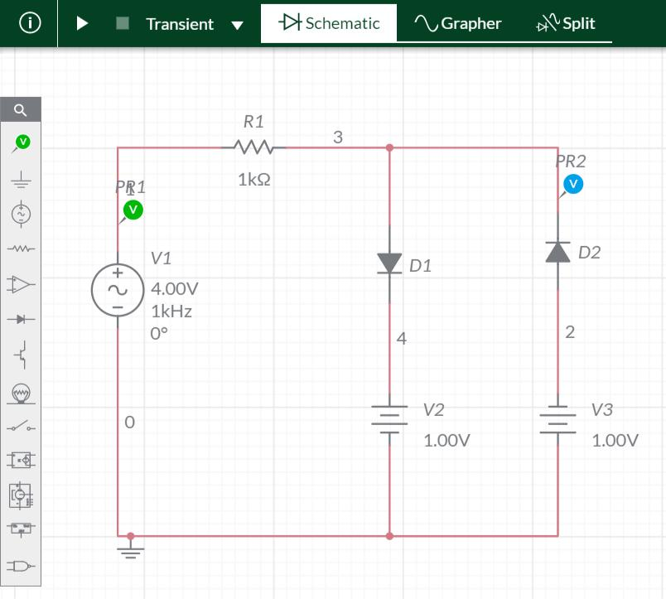

**WAVEFORMS (FROM MULTISIM)**

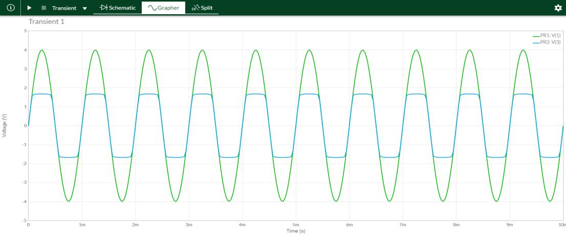

**___________________________________________________**

**CONCLUSIONS:**

Here,The practical and theoretical characteristics of various negative and

positive clipper (with and without bias) circuits are same. Hence verified..

**ASSIGNMENT**



|  |
| --- |
| Page28 |

Exp-1- Diode Clippers ECED, SVNIT

DIGITAL ELECTRONICS AND LOGIC DESIGN[EC - 207]



**SARDAR VALLABHBHAI NATIONAL INSTITUTE OF TECHNOLOGY, SURAT ELECTRONICS ENGINEERINGDEPARTMENT**



**QUE-1:**

**CIRCUIT/CONNECTION DIAGRAMS (FROM MULTISIM**

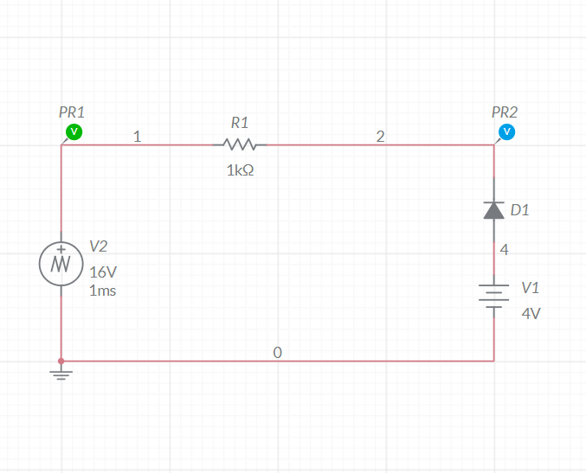

**WAVEFORMS (FROM MULTISIM)**

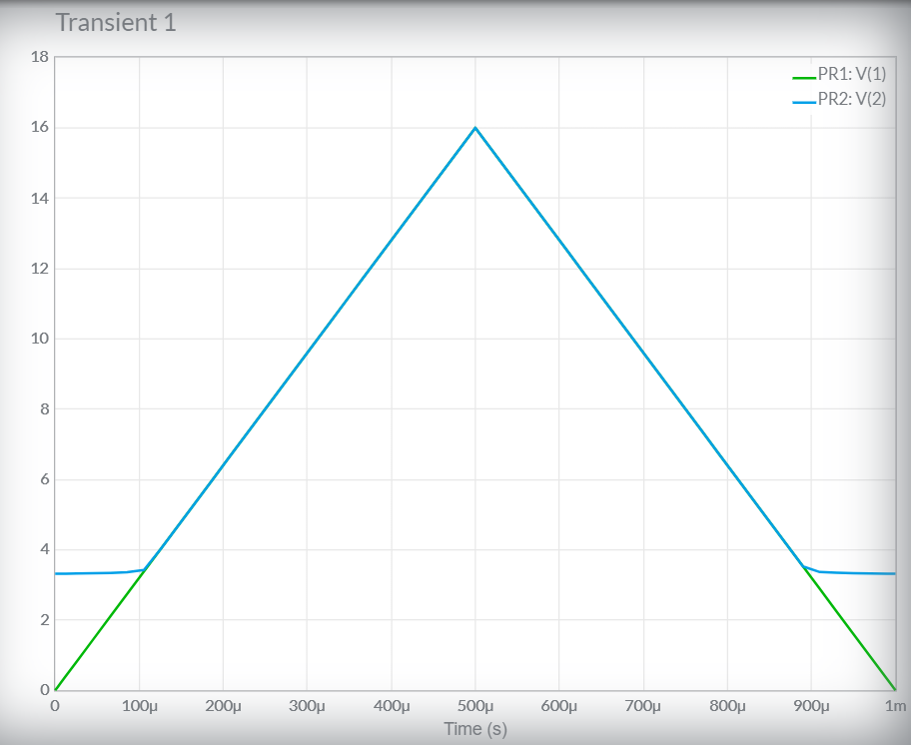

**QUE-2:**



|  |
| --- |
| Page29 |

Exp-1- Diode Clippers ECED, SVNIT

DIGITAL ELECTRONICS AND LOGIC DESIGN[EC - 207]



**SARDAR VALLABHBHAI NATIONAL INSTITUTE OF TECHNOLOGY, SURAT ELECTRONICS ENGINEERINGDEPARTMENT**



**CIRCUIT/CONNECTION DIAGRAMS (FROM MULTISIM)**

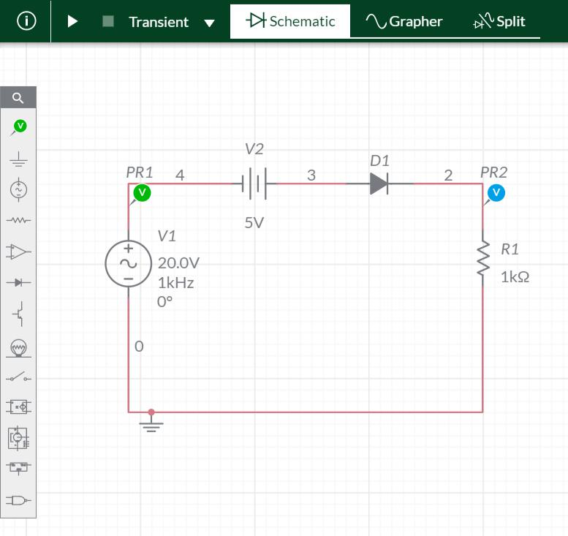

**WAVEFORMS (FROM MULTISIM)**

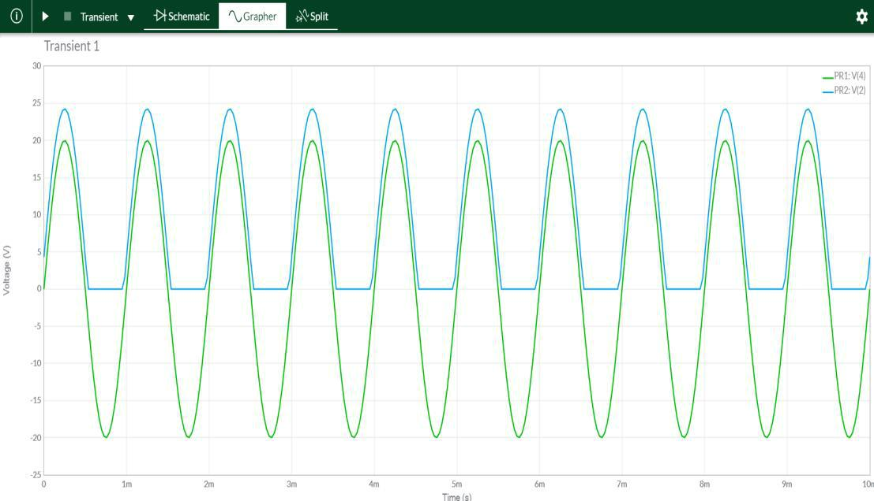

|  |
| --- |
| Page30 |



Exp-1- Diode Clippers ECED, SVNIT